**Minify JavaScript**

May 2, 2019 • Updated Jun 20, 2020

Appears in: [Performance audits](https://web.dev/lighthouse-performance)

Minifying JavaScript files can reduce payload sizes and script parse time. The Opportunities section of your Lighthouse report lists all unminified JavaScript files, along with the potential savings in [kibibytes (KiB)](https://en.wikipedia.org/wiki/Kibibyte) when these files are minified:

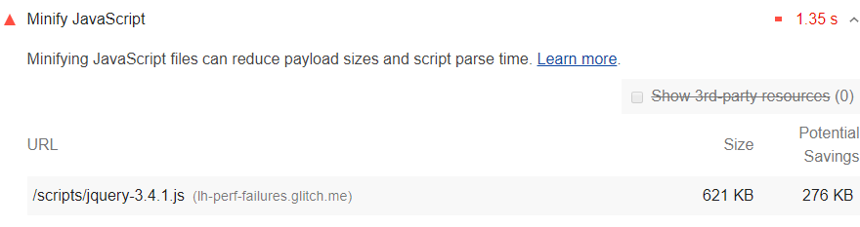

**How to minify your JavaScript files** [**#**](https://web.dev/unminified-javascript/?utm_source=lighthouse&utm_medium=devtools#how-to-minify-your-javascript-files)

Minification is the process of removing whitespace and any code that is not necessary to create a smaller but perfectly valid code file. [Terser](https://github.com/terser-js/terser) is a popular JavaScript compression tool. webpack v4 includes a plugin for this library by default to create minified build files.

**Stack-specific guidance** [**#**](https://web.dev/unminified-javascript/?utm_source=lighthouse&utm_medium=devtools#stack-specific-guidance)

**Drupal** [**#**](https://web.dev/unminified-javascript/?utm_source=lighthouse&utm_medium=devtools#drupal)

Ensure you have enabled **Aggregate JavaScript files** in the **Administration**

**Configuration** > **Development** page. You can also configure more advanced aggregation options through [additional modules](https://www.drupal.org/project/project_module?f%5B0%5D=&f%5B1%5D=&f%5B2%5D=im_vid_3%3A123&f%5B3%5D=&f%5B4%5D=sm_field_project_type%3Afull&f%5B5%5D=&f%5B6%5D=&text=javascript+aggregation&solrsort=iss_project_release_usage+desc&op=Search) to speed up your site by concatenating, minifying, and compressing your JavaScript assets.

**Joomla** [**#**](https://web.dev/unminified-javascript/?utm_source=lighthouse&utm_medium=devtools#joomla)

A number of [Joomla extensions](https://extensions.joomla.org/instant-search/?jed_live%5Bquery%5D=performance) can speed up your site by concatenating, minifying, and compressing your scripts. There are also templates that provide this functionality.

**Magento** [**#**](https://web.dev/unminified-javascript/?utm_source=lighthouse&utm_medium=devtools#magento)

Use [Terser](https://www.npmjs.com/package/terser) to minify all JavaScript assets from static content deployment, and disable the built-in minification feature.

**React** [**#**](https://web.dev/unminified-javascript/?utm_source=lighthouse&utm_medium=devtools#react)

If your build system minifies JS files automatically, ensure that you are deploying the [production build](https://reactjs.org/docs/optimizing-performance.html#use-the-production-build) of your application. You can check this with the React Developer Tools extension.

**WordPress** [**#**](https://web.dev/unminified-javascript/?utm_source=lighthouse&utm_medium=devtools#wordpress)

A number of [WordPress plugins](https://wordpress.org/plugins/search/minify+javascript/) can speed up your site by concatenating, minifying, and compressing your scripts. You may also want to use a build process to do this minification up front if possible.

## What is minification in JavaScript?

Minification, also known as minimization, is the process of removing all unnecessary characters from JavaScript source code without altering its functionality. This includes the removal of whitespace, comments, and semicolons, along with the use of shorter variable names and functions. Minification of JavaScript code results in compact file size.

For example, here is a block of code before and after minification:

Before minification: eight lines of code



After minification: A single line of code



Minification speeds up webpage loading, thereby improving website experience, making both visitors and search engines happy.

## Why don’t developers write minified code to begin with?

Minification results in compact files, which makes it a web performance best practice. So, why not write code that is already minified?

JavaScript code is written for, and by, humans, who need whitespace, formatting, and comments to be able to understand and debug the code. After the code is written, minifying software can be used in order to improve performance. This is because browsers can execute code without needing to understand it.

## What are the disadvantages of minification?

Minification can break complicated scripts because of site-dependent variables like themes, plugins, and server environment. Also, minification must be done in conjunction with other performance tuning. On its own, it might not provide significant gains. Minification can also introduce errors that are hard to debug.